$$∀i^{\left(s\right)}∈\left[1,n^{\left(s\right)}\right]∩Z,s∈\left[1,L\right]∩Z,,t∈\left[1,m\right]∩Z,∃以下定义:$$
定义
$$f\left(x\right)=\left\{\begin{matrix}0, & x≤0, \\ 1-\left(\left\lceil x\right\rceil -x\right), & x>0,\end{matrix} \right.$$
图像如下：
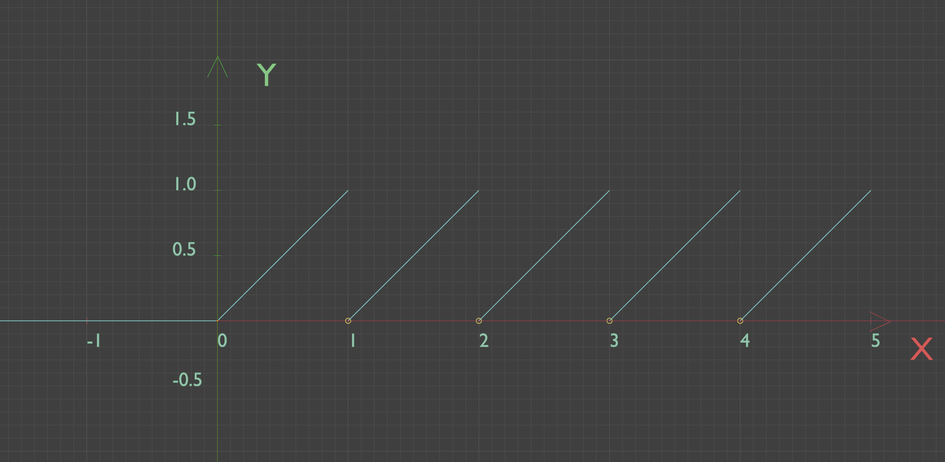
则
$$\frac{∂f\left(x\right)}{∂x}=\left\{\begin{matrix}0, & x≤0 , \\ 1, & x>0,\end{matrix} \right.$$
定义
$$σ(x,b)=\left|f\left(x\right)-b\right|$$
则
$$\frac{∂σ\left(x,b\right)}{∂x}=\frac{∂\left|f\left(x\right)-b\right|}{∂x}=\left(f\left(x\right)-b\right)∙\frac{∂f\left(x\right)}{∂x}$$
如果$s=1$，则
$$a_{i^{\left(1\right)}}^{\left(1\right)\left(t\right)}=\left|x_{i^{\left(1\right)}}^{\left(t\right)}-b_{i^{\left(1\right)}}^{\left(1\right)}\right|$$
如果$s>1$，则
$$\begin{aligned}z_{i^{\left(s\right)}}^{\left(s\right)\left(t\right)}=\sum_{i^{\left(s-1\right)}=1}^{n^{\left(s-1\right)}}{ω_{i^{\left(s-1\right)}i^{\left(s\right)}}^{\left(s-1\right)}a_{i^{\left(s-1\right)}}^{\left(s-1\right)\left(t\right)}}\#\left(1.2.1\right)\end{aligned}$$
$$\begin{aligned}a_{i^{\left(s\right)}}^{\left(s\right)\left(t\right)}=σ\left(z_{i^{\left(s\right)}}^{\left(s\right)\left(t\right)},b_{i^{\left(s\right)}}^{\left(s\right)}\right)=\left|f\left(z_{i^{\left(s\right)}}^{\left(s\right)\left(t\right)}\right)-b_{i^{\left(s\right)}}^{\left(s\right)}\right|\#\left(1.1.1\right)\end{aligned}$$
定义
$$\begin{aligned}loss=\frac{1}{m}\sum_{t=1}^{m}{\left[\sqrt{\sum_{i^{\left(L\right)}=1}^{n^{\left(L\right)}}{{\left(a_{i^{\left(L\right)}}^{\left(L\right)\left(t\right)}-y_{i^{\left(L\right)}}^{\left(t\right)}\right)}^{2}}}\right]}\#\left(1.1.3\right)\end{aligned}$$
$$\begin{aligned}loss^{\left(t\right)}=\sqrt{\sum_{i^{\left(L\right)}=1}^{n^{\left(L\right)}}{{\left(a_{i^{\left(L\right)}}^{\left(L\right)\left(t\right)}-y_{i^{\left(L\right)}}^{\left(t\right)}\right)}^{2}}}\#\left(1.1.2\right)\end{aligned}$$
则
$$\begin{aligned}loss=\frac{1}{m}\sum_{t=1}^{m}{loss^{\left(t\right)}}\#\left(1.1.4\right)\end{aligned}$$
设定
$$\begin{aligned}ω_{i^{\left(s-1\right)}i^{\left(s\right)}}^{\left(s-1\right)}=f\left(q_{i^{\left(s-1\right)}}^{\left(s-1\right)}∙δ\left(p_{i^{\left(s-1\right)}}^{\left(s-1\right)},i^{\left(s\right)}\right)+l_{i^{\left(s\right)}}^{\left(s\right)}∙δ\left(i^{\left(s-1\right)},i^{\left(s\right)}-1\right)+r_{i^{\left(s\right)}}^{\left(s\right)}∙δ\left(i^{\left(s-1\right)},i^{\left(s\right)}+1\right)\right)\#\left(1.3.1\right)\end{aligned}$$
其中
$$δ\left(p,i\right)=\left\{\begin{matrix}1, & p=i, \\ 0, & p≤i-1或p≥i+1,\end{matrix} \right.$$
此处设定
$$δ\left(p,i\right)=\left\{\begin{matrix}i-p+1, & i≤p<i+1, \\ 0, & p<i或p≥i+1,\end{matrix} \right.$$
则
$$\frac{∂δ\left(p,i\right)}{∂p}=\left\{\begin{matrix}-1, & i≤p<i+1, \\ 0, & p<i或p≥i+1,\end{matrix} \right.$$

开始推导：
假设s<L且s离L无限远，
选取超参进行推导：
对于$b_{i^{\left(s\right)}}^{\left(s\right)}$，根据式$\left(1.1.1\right)$，可知$b_{i^{\left(s\right)}}^{\left(s\right)}$在每一个$a_{i^{\left(s\right)}}^{\left(s\right)\left(t\right)}$里，由式$\left(1.1.2\right)$可知$a_{i^{\left(s\right)}}^{\left(s\right)\left(t\right)}$在$loss^{\left(t\right)}$里，由式$\left(1.1.4\right)$可知 $loss^{\left(t\right)}$在$loss$里，则
$$\frac{∂loss}{∂b_{i^{\left(s\right)}}^{\left(s\right)}}=\frac{∂\frac{1}{m}\sum_{t=1}^{m}{loss^{(t)}}}{∂b_{i^{\left(s\right)}}^{\left(s\right)}}=\frac{1}{m}\sum_{t=1}^{m}{\frac{∂loss^{\left(t\right)}}{∂b_{i^{\left(s\right)}}^{\left(s\right)}}}=\frac{1}{m}\sum_{t=1}^{m}{\frac{∂loss^{\left(t\right)}}{∂a_{i^{\left(s\right)}}^{\left(s\right)\left(t\right)}}}∙\frac{∂a_{i^{\left(s\right)}}^{\left(s\right)\left(t\right)}}{∂b_{i^{\left(s\right)}}^{\left(s\right)}}$$
所以想算$b_{i^{\left(s\right)}}^{\left(s\right)}$，要先算出$\frac{∂loss^{\left(t\right)}}{∂a_{i^{\left(s\right)}}^{\left(s\right)\left(t\right)}}$
对于$ω_{i^{\left(s-1\right)}i^{\left(s\right)}}^{\left(s-1\right)}$，根据式$\left(1.2.1\right)$可知$ω_{i^{\left(s-1\right)}i^{\left(s\right)}}^{\left(s-1\right)}$在$z_{i^{\left(s\right)}}^{\left(s\right)\left(t\right)}$中，由式$\left(1.1.1\right)$可知$z_{i^{\left(s\right)}}^{\left(s\right)\left(t\right)}$在$a_{i^{\left(s\right)}}^{\left(s\right)\left(t\right)}$中，所以同理，想算$ω_{i^{\left(s-1\right)}i^{\left(s\right)}}^{\left(s-1\right)}$，要先算出$\frac{∂loss^{\left(t\right)}}{∂a_{i^{\left(s\right)}}^{\left(s\right)\left(t\right)}}$，然后算出$\frac{∂loss^{\left(t\right)}}{∂z_{i^{\left(s\right)}}^{\left(s\right)\left(t\right)}}$
至于$p_{i^{\left(s-1\right)}}^{\left(s-1\right)}$、$q_{i^{\left(s-1\right)}}^{\left(s-1\right)}$、$l_{i^{\left(s\right)}}^{\left(s\right)}$、$r_{i^{\left(s\right)}}^{\left(s\right)}$，由式$\left(1.3.1\right)$可知它们在$ω_{i^{\left(s-1\right)}i^{\left(s\right)}}^{\left(s-1\right)}$中，所以同理，要先算出$\frac{∂loss^{\left(t\right)}}{∂a_{i^{\left(s\right)}}^{\left(s\right)\left(t\right)}}$，所以我们先来计算$\frac{∂loss^{\left(t\right)}}{∂a_{i^{\left(s\right)}}^{\left(s\right)\left(t\right)}}$

